21.16: 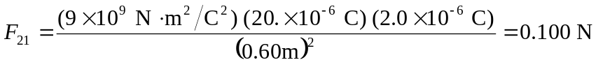

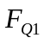 is equal and opposite to 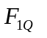(Ex. 21.4), so
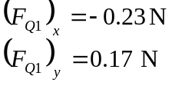
Overall:
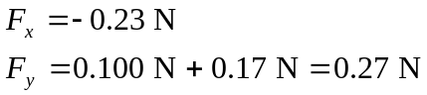
The magnitude of the total force is 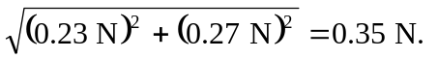The direction of the force, as measured from the +y axis is
